Abstract-- This document gives formatting instructions for authors preparing papers for publication in the Proceedings of an IEEE sponsored 2nd National Conference Power & Energy System Conference (NPESC 2015). The document contains information regarding desktop publishing format, type sizes, and typefaces. Style rules are provided that explains how to handle equations, units, figures, tables, abbreviations, and acronyms. Sections are also devoted to the preparation of acknowledgments, references, and authors' biographies. The abstract is limited to 150 words and cannot contain equations, figures, tables, or references. It should concisely state what was done, how it was done, principal results, and their significance.
Paper for IEEE Sponsored 2nd National Power & Energy Systems Conference (Paper Title)
A. Author, Student Member, IEEE, B. Author, Member, IEEE, and C. Author, Student Member, IEEE

Index Terms--The author shall provide up to 5-6 keywords (in alphabetical order) to help identify the major topics of the paper.

Introduction
THIS document provides an example of the desired layout for a NPESC 2014 and can be used as a Microsoft Word template. It contains information regarding desktop publishing format, type sizes, and typefaces. Style rules are provided that explains how to handle equations, units, figures, tables, abbreviations, and acronyms.

Paper Preparation
Please use automatic hyphenation and check your spelling. Additionally, be sure your sentences are complete and that there is continuity within your paragraphs. Check the numbering of your graphics (figures and tables) and make sure that all appropriate references are included.

Page Layout
An easy way to comply with the conference paper formatting requirements is to use this document as a template and simply type your text into it.
- Page Layout
Your paper must use a page size corresponding to A4 which is 210mm (8.27") wide and 297mm (11.69") long. The margins must be set as follows:
- Top = 19 mm (0.75")
- Bottom = 43 mm (1.69")
- Left = Right = 14.32mm (0.56")
Your paper must be in two column format with a space of 4.22mm (0.17") between columns.

Page Style
All paragraphs must be indented. All paragraphs must be justified, i.e. both left-justified and right-justified.
- Text Font of Entire Document
The entire document should be in Times New Roman or Times font. Type 3 fonts must not be used. Other font types may be used if needed for special purposes.
Recommended font sizes are shown in Table 1.
- Title and Author Details
Title must be in 24 pt Regular font. Author name must be in 11 pt Regular font.
Body of the paper should be in 10 pt font.
All title and author details must be in single-column format and must be centered.
Every word in a title must be capitalized except for short minor words such as “a”, “an”, “and”, “as”, “at”, “by”, “for”, “from”, “if”, “in”, “into”, “on”, “or”, “of”, “the”, “to”, “with”.
Author details must not show any professional title (e.g. Managing Director), any academic title (e.g. Dr.) etc.
To avoid confusion, the family name must be written as the last part of each author name (e.g. Rajendra P. Sharma).
Each affiliation must include, at the very least, the name of the company and the name of the country where the author is based (e.g. Institute of Technology, Lucknow, India).
Email address is compulsory for the corresponding author.
Extra Care should be taken in order to ensure that conference paper will be free from grammar and spelling mistakes.
Below the table and figure captions 6pt spacing is needed.
TABLE I
Font Sizes for Papers
Font Size | Appearance (in Time New Roman or Times)
Font Size | Regular | Bold | Italic
8 | table caption (in Small Caps),  figure caption,  reference item |  | reference item (partial)
9 | author email address (in Courier),  cell in a table | abstract body | abstract heading (also in Bold)
10 | level-1 heading (in Small Caps),  paragraph |  | level-2 heading,  level-3 heading,  author affiliation
11 | author name
24 | title
- Section Headings
No more than 3 levels of headings should be used. All headings must be in 10pt font. Every word in a heading must be capitalized except for short minor words as listed in Section III-B.
- Level-1 Heading: A level-1 heading must be in Small Caps, centered and numbered using uppercase Roman numerals. For example, see heading “III. Page Style” of this document. The two level-1 headings which must not be numbered are “Acknowledgment” and “References”.
- Level-2 Heading: A level-2 heading must be in Italic, left-justified and numbered using an uppercase alphabetic letter followed by a period. For example, see heading “C. Section Headings” above.
- Level-3 Heading: A level-3 heading must be indented, in Italic and numbered with an Arabic numeral followed by a right parenthesis. The level-3 heading must end with a colon. The body of the level-3 section immediately follows the level-3 heading in the same paragraph. For example, this paragraph begins with a level-3 heading.
- Table Captions
Tables must be numbered using uppercase Roman numerals. Table captions must be centred and in 8 pt Regular font with Small Caps. Every word in a table caption must be capitalized except for short minor words as listed in Section III-B. Captions with table numbers must be placed before their associated tables, as shown in Table 1.
- Page Numbers, Headers and Footers
Page numbers, headers and footers must not be used
- Figures and Tables
Figure axis labels are often a source of confusion. Try to use words rather than symbols. As an example, write the quantity "Magnetization," or "Magnetization, M," not just "M." Put units in parentheses. Do not label axes only with units. As in Fig. 1, write "Magnetization (kA/m)" or "Magnetization (kA·m⁻¹)," not just "kA/m." Do not label axes with a ratio of quantities and units. For example, write "Temperature (K)," not "Temperature/K." Figure labels should be legible, approximately 8- to 10-point type.
Large figures and tables may span both columns, but may not extend into the page margins. Figure captions should be below the figures; table captions should be above the tables. Do not put captions in "text boxes" linked to the figures. Do not put borders around your figures.
All figures and tables must be in place in the text near, but not before, where they are first mentioned. Use the abbreviation "Fig. 1," even at the beginning of a sentence.
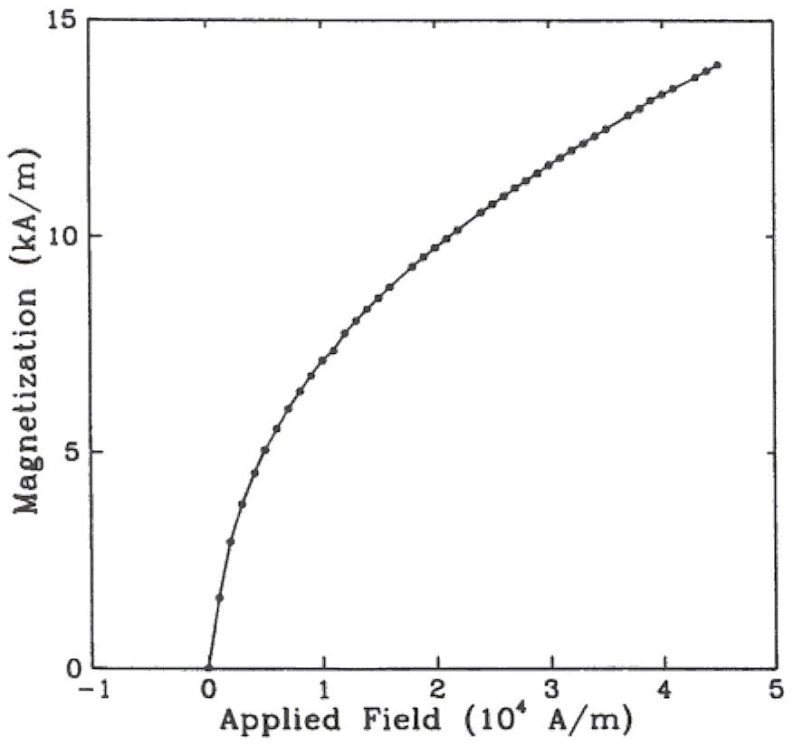
Fig. 1. Magnetization as a function of applied field. (Note that "Fig." is abbreviated and there is a period after the figure number followed by two spaces.)
- Numbering
Number reference citations consecutively in square brackets [1]. The sentence punctuation follows the brackets [2]. Multiple references [2], [3] are each numbered with separate brackets [1]-[3]. Refer simply to the reference number, as in [3]. Do not use "Ref. [3]" or "reference [3]" except at the beginning of a sentence: "Reference [3] shows…."
Number footnotes separately with superscripts (Insert | Footnote). Place the actual footnote at the bottom of the column in which it is cited. Do not put footnotes in the reference list. Use letters for table footnotes.
Check that all figures and tables are numbered correctly. Use arabic numerals for figures and Roman numerals for tables.
Appendix figures and tables should be numbered consecutively with the figures and tables appearing in the rest of the paper. They should not have their own numbering system.
- Units
Metric units are preferred for use in IEEE publications in light of their global readership and the inherent convenience of these units in many fields. In particular, the use of the International System of Units (Systeme Internationale d'Unites or SI Units) is advocated. This system includes a subsystem of units based on the meter, kilogram, second, and ampere (MKSA). British units may be used as secondary units (in parentheses). An exception is when British units are used as identifiers in trade, such as 3.5-inch disk drive.
- Abbreviations and Acronyms
Define less common abbreviations and acronyms the first time they are used in the text, even after they have been defined in the abstract. Abbreviations such as IEEE, SI, MKS, CGS, ac, dc, and rms do not have to be defined. Do not use abbreviations in the title unless they are unavoidable.
- Math and Equations
Use either the Microsoft Equation Editor or the Math Type commercial add-on for MS Word for all math objects in your paper (Insert | Object | Create New | Microsoft Equation or Math Type Equation). "Float over text" should not be selected.
To make your equations more compact, you may use the solidus ( / ), the exp function, or appropriate exponents. Italicize Roman symbols for quantities and variables, but not Greek symbols. Use a long dash rather than a hyphen for a minus sign. Use parentheses to avoid ambiguities in denominators.
Number equations consecutively with equation numbers in parentheses flush with the right margin, as in (1). Be sure that the symbols in your equation have been defined before the equation appears or immediately following.
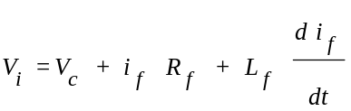 (1)
where V_{i} is the instantaneous voltage.
Use "(1)," not "Eq. (1)" or "equation (1)," except at the beginning of a sentence: "Equation (1) is .…"

Appendix
Appendixes, if needed, appear before the acknowledgment.

Acknowledgment
The following is an example of an acknowledgment. (Please note that financial support should be acknowledged in the unnumbered footnote on the title page.)
The authors gratefully acknowledge the contributions of I. X. Austan, A. H. Burgmeyer, C. J. Essel, and S. H. Gold for their work on the original version of this document.

References
References are important to the reader; therefore, each citation must be complete and correct. There is no editorial check on references; therefore, an incomplete or wrong reference will be published unless caught by a reviewer or discusser and will detract from the authority and value of the paper. References should be readily available publications.
List only one reference per reference number. If a reference is available from two sources, each should be listed as a separate reference. Give all authors' names; do not use et al. Samples of the correct formats for various types of references are given below.

- G. Eason, B. Noble, and I. N. Sneddon, “On certain integrals of Lipschitz-Hankel type involving products of Bessel functions,” Phil. Trans. Roy. Soc. London, vol. A247, pp. 529–551, April 1955. (references)
- J. Clerk Maxwell, A Treatise on Electricity and Magnetism, 3rd ed., vol. 2. Oxford: Clarendon, 1892, pp.68–73.
- I. S. Jacobs and C. P. Bean, “Fine particles, thin films and exchange anisotropy,” in Magnetism, vol. III, G. T. Rado and H. Suhl, Eds. New York: Academic, 1963, pp. 271–350.
- K. Elissa, “Title of paper if known,” unpublished.
- R. Nicole, “Title of paper with only first word capitalized,” J. Name Stand. Abbrev., in press.
- Y. Yorozu, M. Hirano, K. Oka, and Y. Tagawa, “Electron spectroscopy studies on magneto-optical media and plastic substrate interface,” IEEE Transl. J. Magn. Japan, vol. 2, pp. 740–741, August 1987 [Digests 9th Annual Conf. Magnetics Japan, p. 301, 1982].
- M. Young, The Technical Writer's Handbook. Mill Valley, CA: University Science, 1989.

 The paper title should be in uppercase and lowercase letters, not all uppercase. The name and affiliation (including city and country) of each author must appear on the paper. Full names of authors are preferred in the author line, but are not required. Initials are used in the affiliation footnotes (see below). Put a space between authors' initials. Examples of affiliation footnotes: A. Author is with the Department of Electrical Engineering, Kamla Nehru Institute of Technology, Sultanpur-228118, India (e-mail: a_author@gmail.com). B. Author and C. Author are with the Department of Mechanical Engineering, Kamla Nehru Institute of Technology, Sultanpur-228118, India (e-mail: b_author@gmail.com, c_author@mnnit.ac.in).

